Supplement to the ‘Template for designing cases in learning activities’

By simulating real-world situations, cases can help students to connect theory and practice and challenge them to engage in problems they are likely to encounter in their professions.
The following principles are suggested to be used in the creation of cases.

Relevant
- Cases should reflect the students’ background and levers of learning
- Cases should address the goals and objectives of both students and teachers
- Cases should be set in a realistic and relevant practice setting (e.g. hospital). The setting should be provided in the beginning of the scenario.

Realistic
- Authenticity is important and should be incorporated into cases by adding tasks and problem-solving skills that learners are likely to encounter in practice. Include quotations to increase authenticity.
- Gradual disclosure of content simulates ‘the real world’. Add new information gradually in the case.

Engaging
- Rich and sufficient content that allows multiple levels of analysis and interpretation
- Multiple voices and perspectives should be added (e.g. families)
Challenging
- Cases can differ in difficulty, e.g., by adding tasks, problems, uncertainty or possibilities for multiple solutions.
- Include cases that are rare or unusual
- Include multiples cases in a series e.g., an episode of care or aging process.

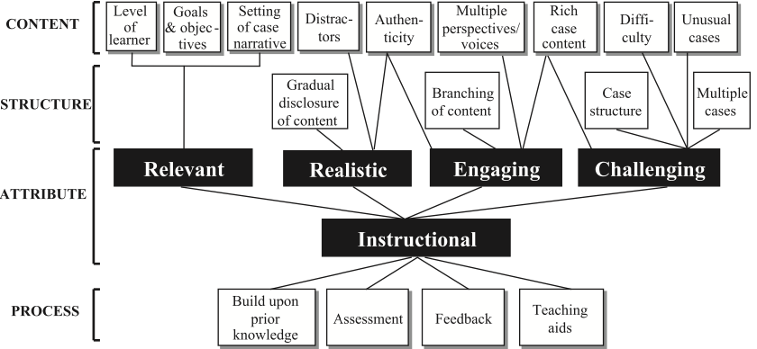

Reference: Kim S, Phillips WR, Pinsky L, Brock D, Phillips K, Keary J. A conceptual framework for developing teaching cases: a review and synthesis of the literature across disciplines. Med Educ. 2006 Sep;40(9):867-76. doi: 10.1111/j.1365-2929.2006.02544.x. PMID: 16925637.

